Go to the list of Shibboleth federations on ASCE Library through one of two ways
浏览ASCE数据库Shibboleth名单列表的两种方法

1. Select the “Find My Institution” link at the top-right corner of the homepage:
1. 选择主页右上角的“查找我的单位”链接
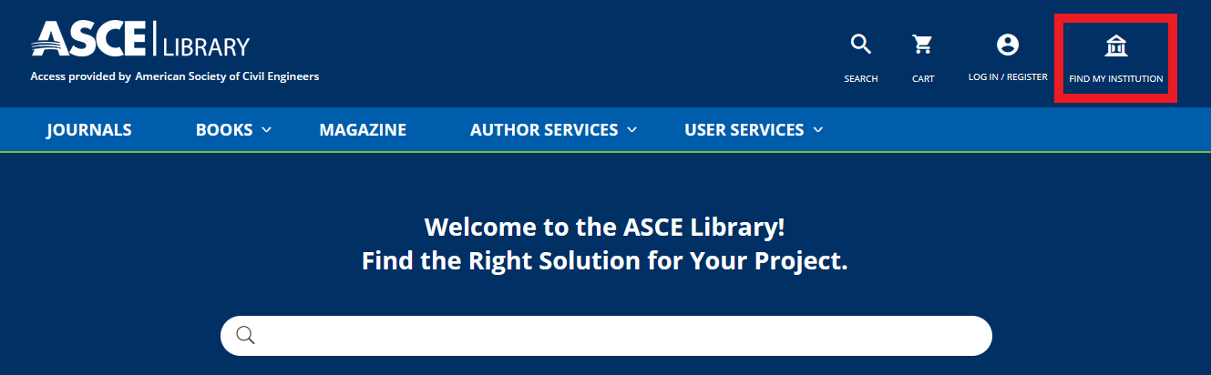

2a. Select the “Download” link from an article page:
2a. 从文章页面选择“下载”链接

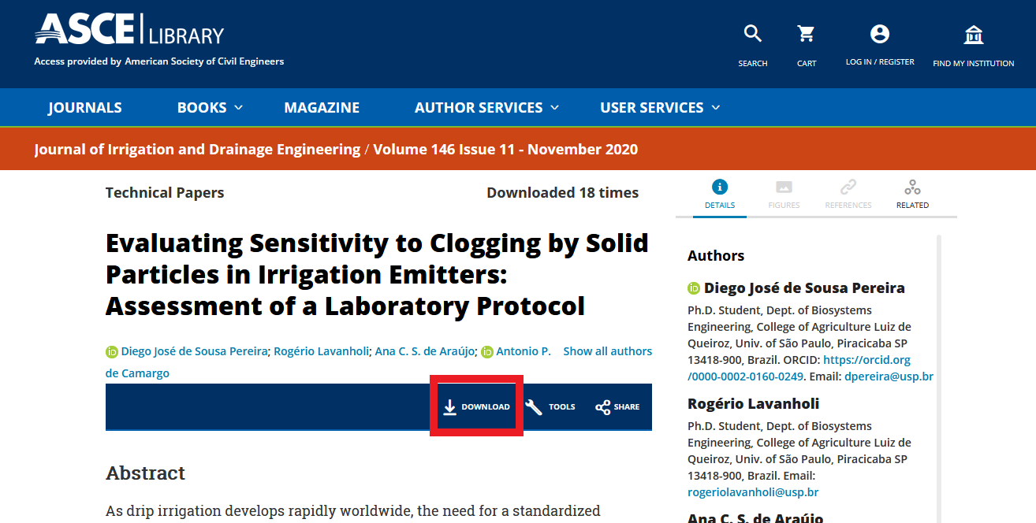

2b. Then select the “Log in via your institution (Shibboleth)” link:
2b. 然后选择“通过您的单位登录（Shibboleth)”链接：
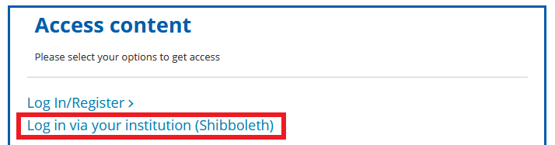

Select your organization from the list of Shibboleth federations by browsing or searching
通过浏览或搜索从Shibboleth名单列表中选择您的单位

1. By browsing:
1.浏览:
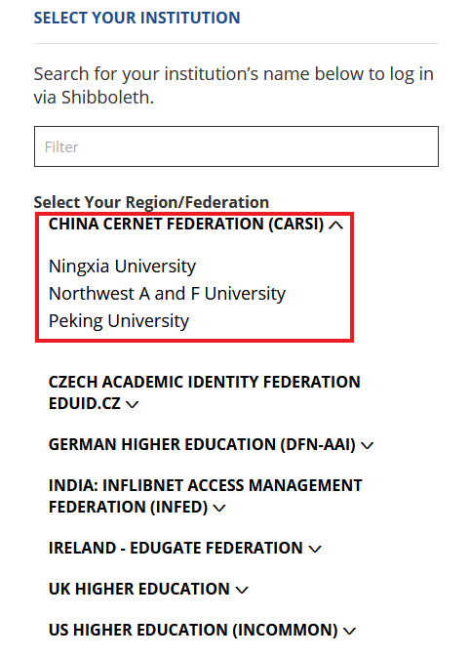

2. By searching. As you type, the list of organizations will filter:
2. 搜索: 在您输入字符时会出现对应的单位名称

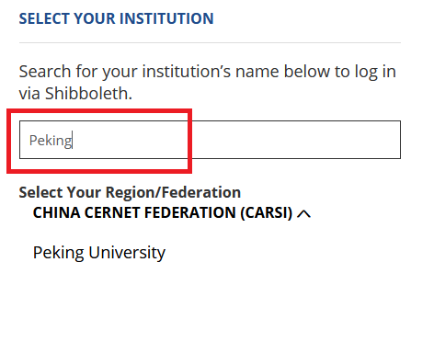

After selecting your organization, log in to access ASCE Library publications
选择您的单位后，便可登录进入ASCE的网站

